Test Case: runTestMultipleTimes
Step 1 - Enter username and password and click to button Enter : Credentials Entered
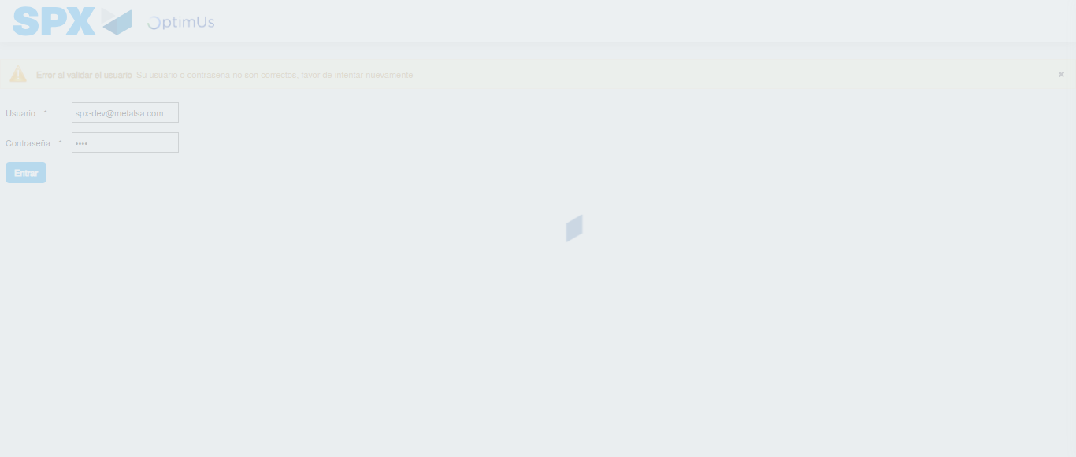Image file-name: QC_Testing-runTestMultipleTimes-dic. 04 2025, 03 43 04 p. m.

Step 2 - Select to UEN and Access to Spot Buy Requisitions : UEN Correctly selected and Correct access
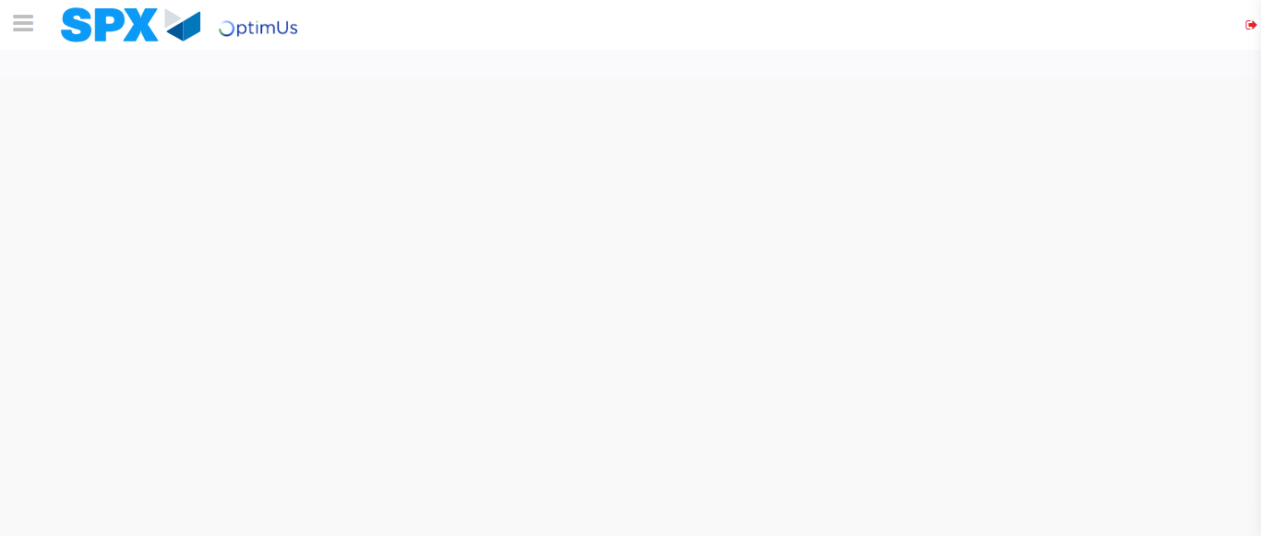Image file-name: QC_Testing-runTestMultipleTimes-dic. 04 2025, 03 43 08 p. m.

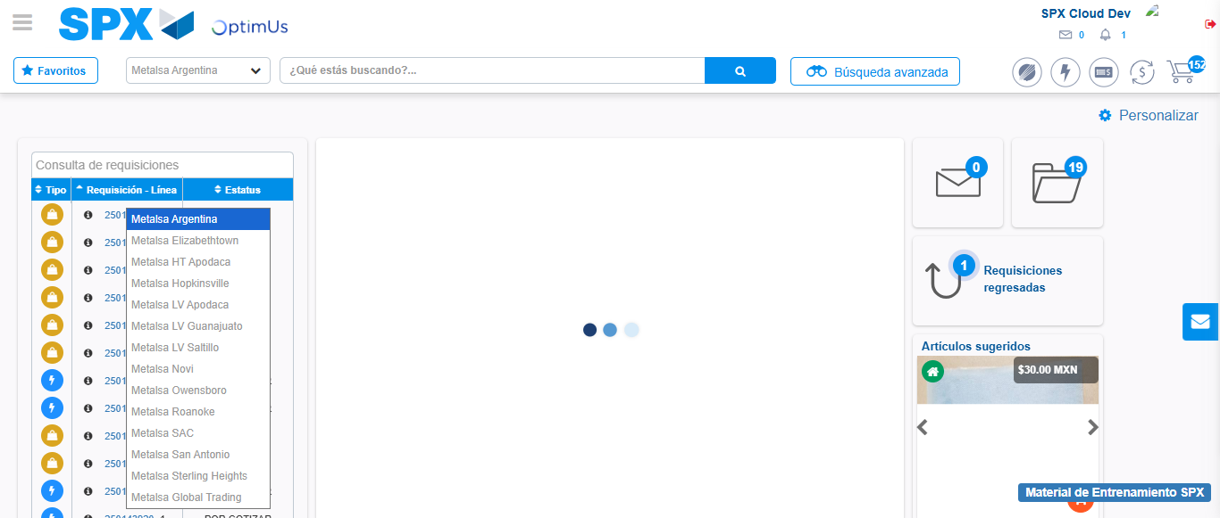Image file-name: QC_Testing-runTestMultipleTimes-dic. 04 2025, 03 43 09 p. m.

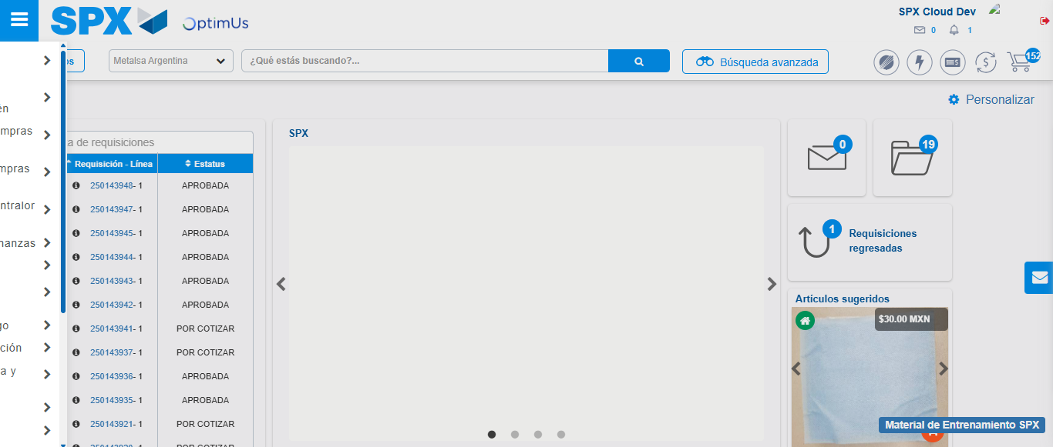Image file-name: QC_Testing-runTestMultipleTimes-dic. 04 2025, 03 43 10 p. m.

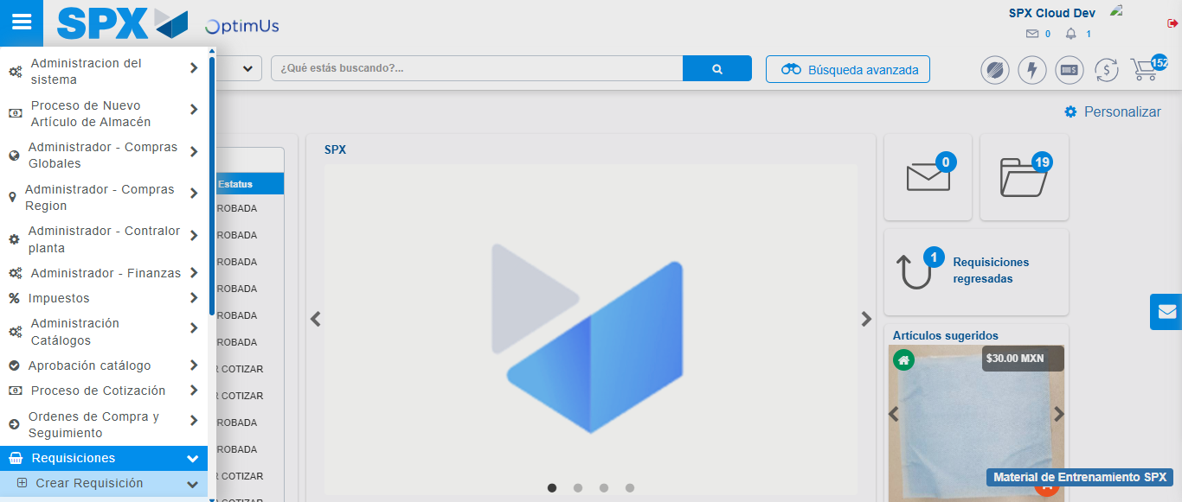Image file-name: QC_Testing-runTestMultipleTimes-dic. 04 2025, 03 43 11 p. m.

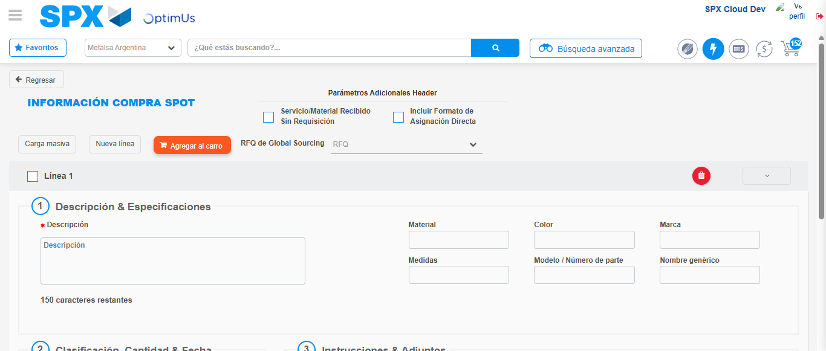Image file-name: QC_Testing-runTestMultipleTimes-dic. 04 2025, 03 43 14 p. m.

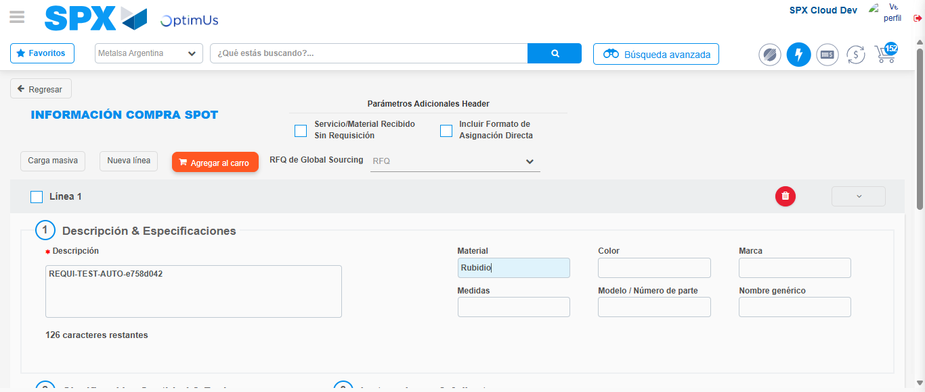Image file-name: QC_Testing-runTestMultipleTimes-dic. 04 2025, 03 43 15 p. m.

Step 3 - Data Capture Spot Buy Requisition: Data captured correctly
Image file-name: QC_Testing-runTestMultipleTimes-dic. 04 2025, 03 43 15 p. m.

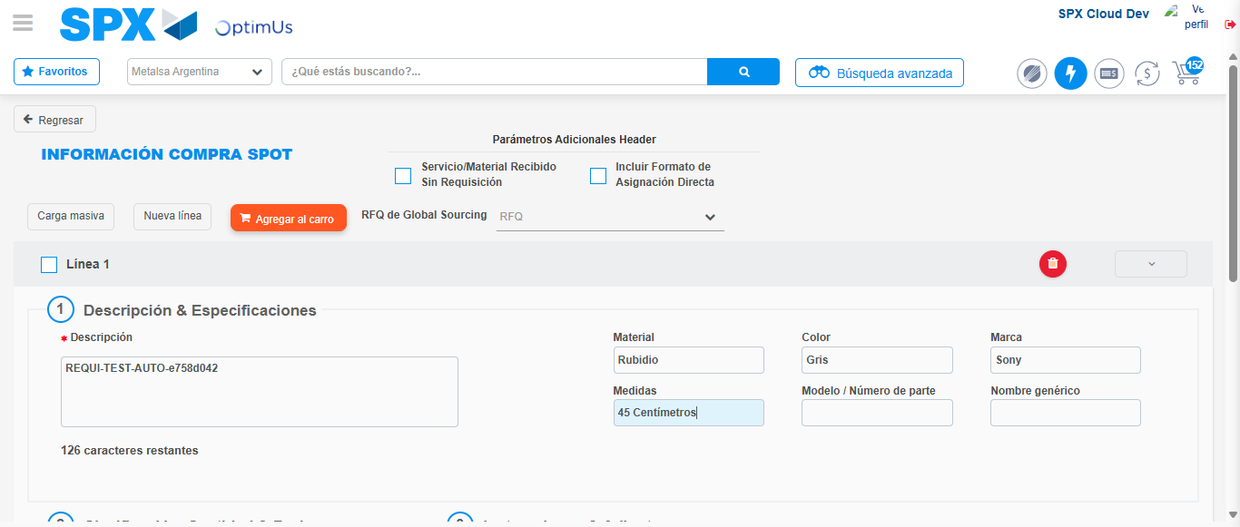Image file-name: QC_Testing-runTestMultipleTimes-dic. 04 2025, 03 43 16 p. m.

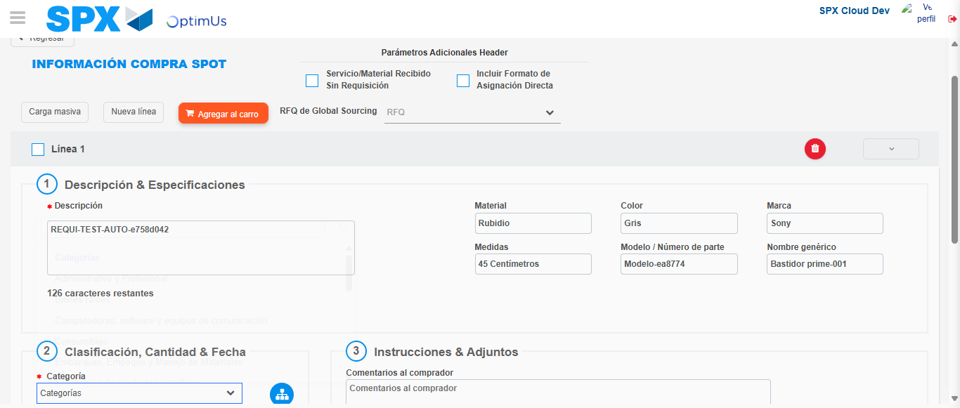Image file-name: QC_Testing-runTestMultipleTimes-dic. 04 2025, 03 43 17 p. m.

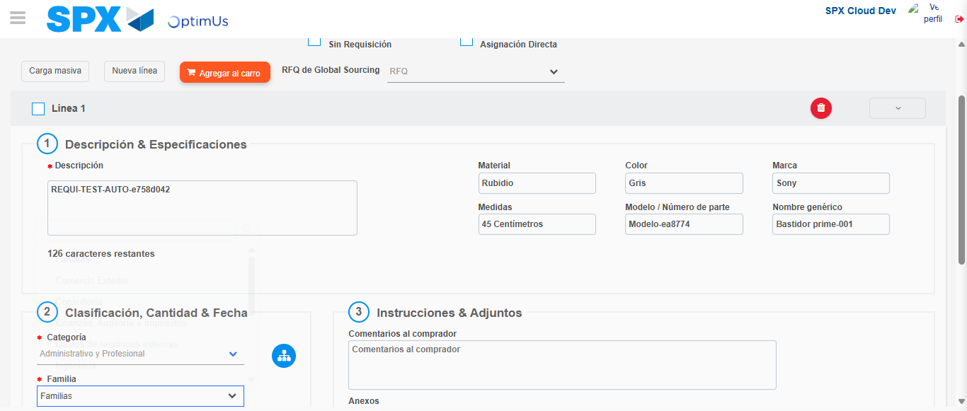Image file-name: QC_Testing-runTestMultipleTimes-dic. 04 2025, 03 43 18 p. m.

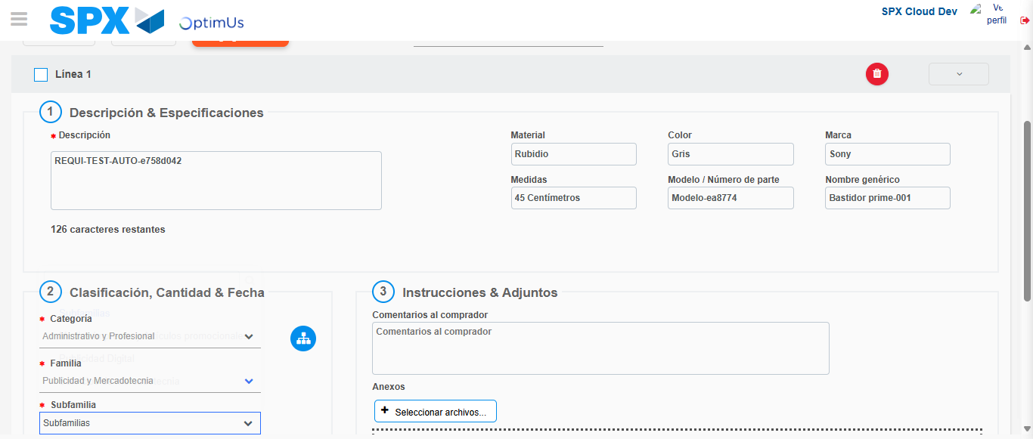Image file-name: QC_Testing-runTestMultipleTimes-dic. 04 2025, 03 43 19 p. m.

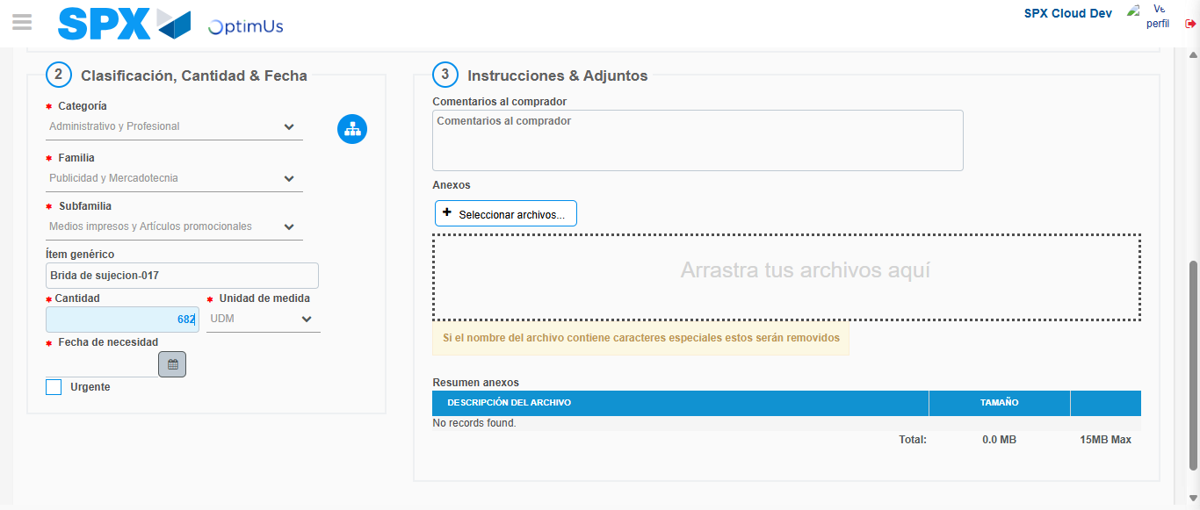Image file-name: QC_Testing-runTestMultipleTimes-dic. 04 2025, 03 43 20 p. m.

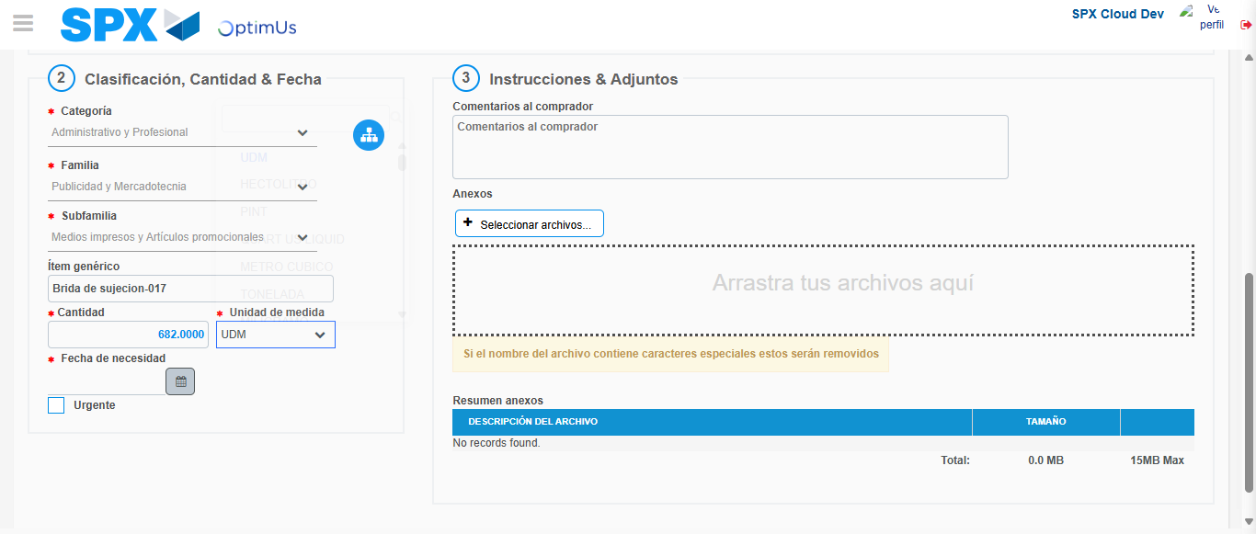Image file-name: QC_Testing-runTestMultipleTimes-dic. 04 2025, 03 43 21 p. m.

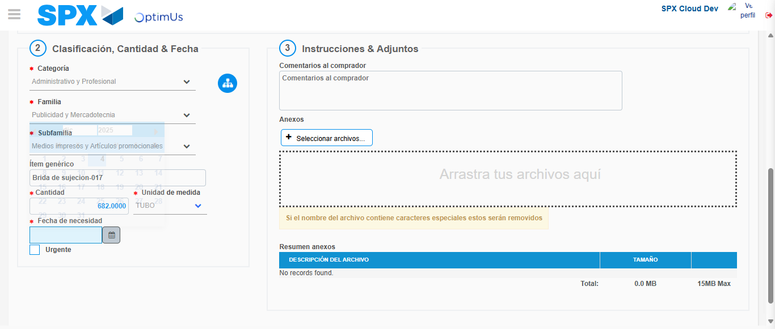Image file-name: QC_Testing-runTestMultipleTimes-dic. 04 2025, 03 43 22 p. m.

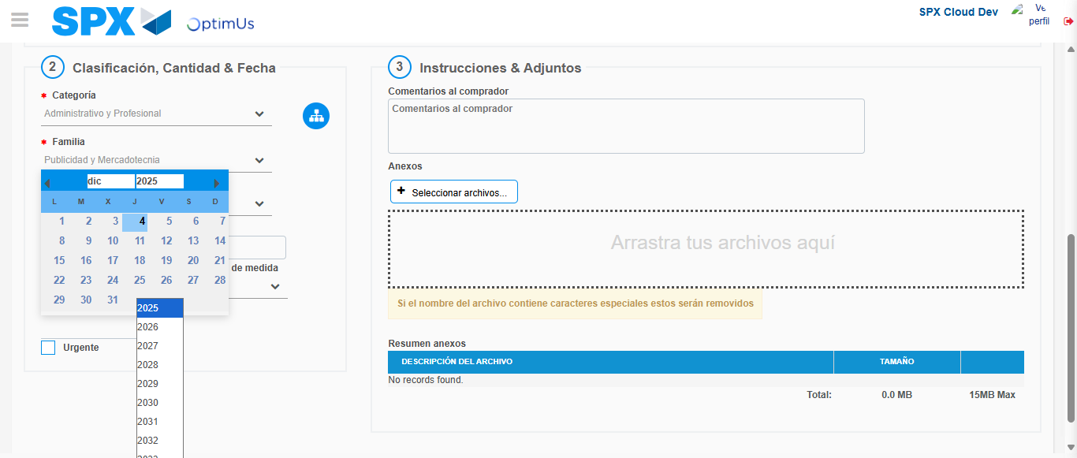Image file-name: QC_Testing-runTestMultipleTimes-dic. 04 2025, 03 43 23 p. m.

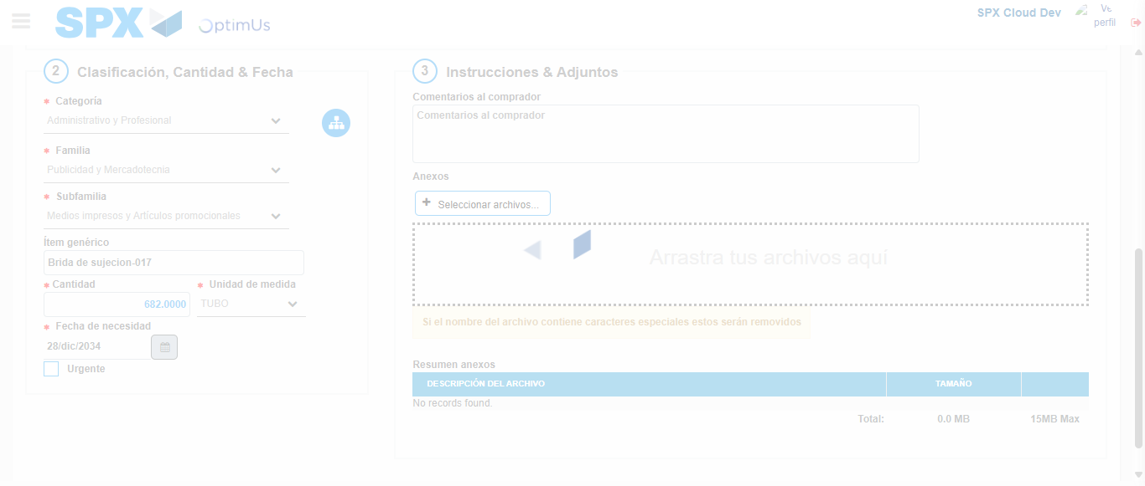Image file-name: QC_Testing-runTestMultipleTimes-dic. 04 2025, 03 43 24 p. m.

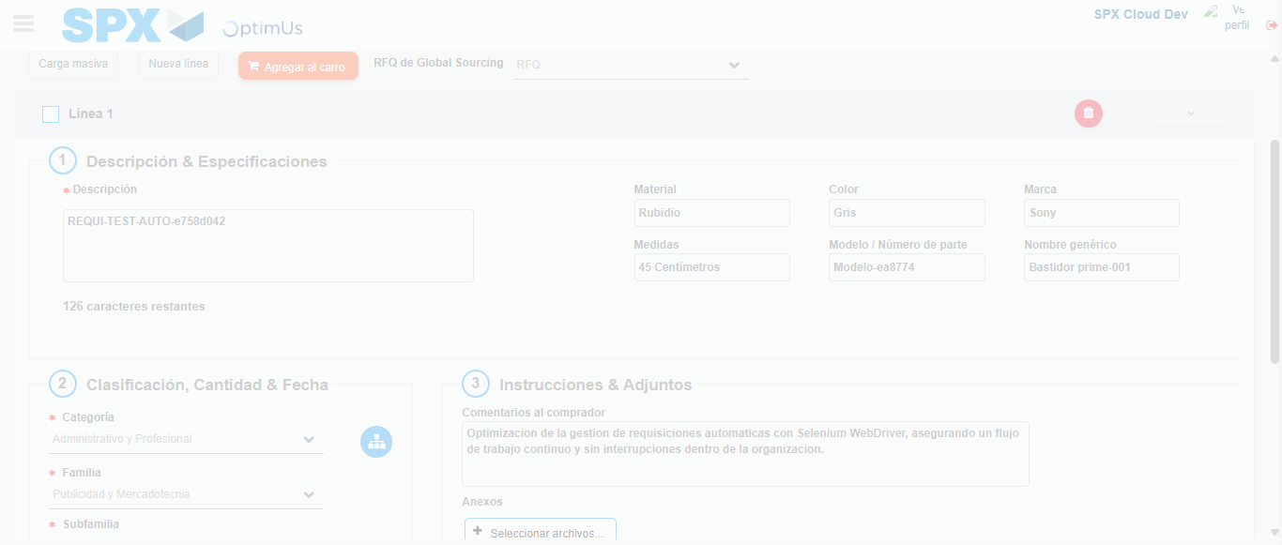Image file-name: QC_Testing-runTestMultipleTimes-dic. 04 2025, 03 43 25 p. m.

Step 4 - Add new line and data capture second line: Line add correctly
Image file-name: QC_Testing-runTestMultipleTimes-dic. 04 2025, 03 43 15 p. m.

Image file-name: QC_Testing-runTestMultipleTimes-dic. 04 2025, 03 43 16 p. m.

Image file-name: QC_Testing-runTestMultipleTimes-dic. 04 2025, 03 43 17 p. m.

Image file-name: QC_Testing-runTestMultipleTimes-dic. 04 2025, 03 43 18 p. m.

Image file-name: QC_Testing-runTestMultipleTimes-dic. 04 2025, 03 43 19 p. m.

Image file-name: QC_Testing-runTestMultipleTimes-dic. 04 2025, 03 43 20 p. m.

Image file-name: QC_Testing-runTestMultipleTimes-dic. 04 2025, 03 43 21 p. m.

Image file-name: QC_Testing-runTestMultipleTimes-dic. 04 2025, 03 43 22 p. m.

Image file-name: QC_Testing-runTestMultipleTimes-dic. 04 2025, 03 43 23 p. m.

Image file-name: QC_Testing-runTestMultipleTimes-dic. 04 2025, 03 43 24 p. m.

Image file-name: QC_Testing-runTestMultipleTimes-dic. 04 2025, 03 43 25 p. m.

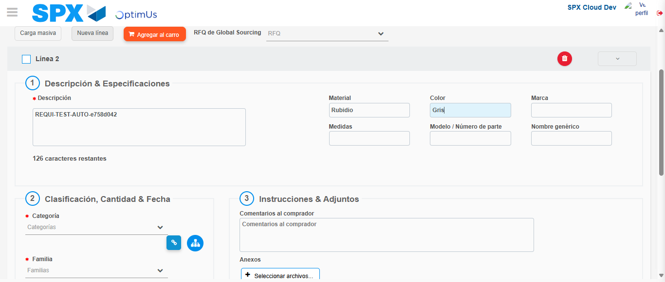Image file-name: QC_Testing-runTestMultipleTimes-dic. 04 2025, 03 43 29 p. m.

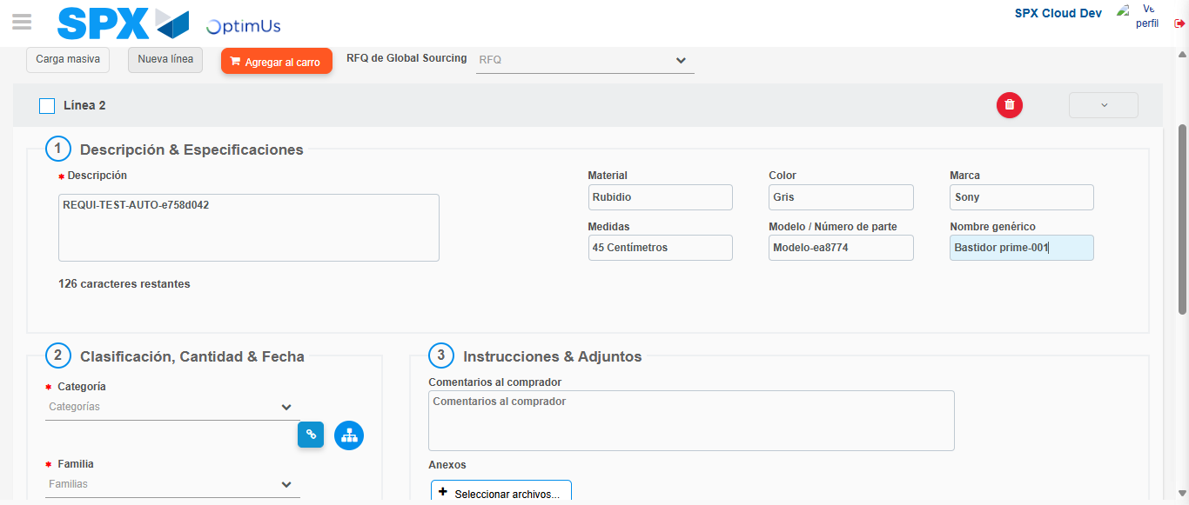Image file-name: QC_Testing-runTestMultipleTimes-dic. 04 2025, 03 43 30 p. m.

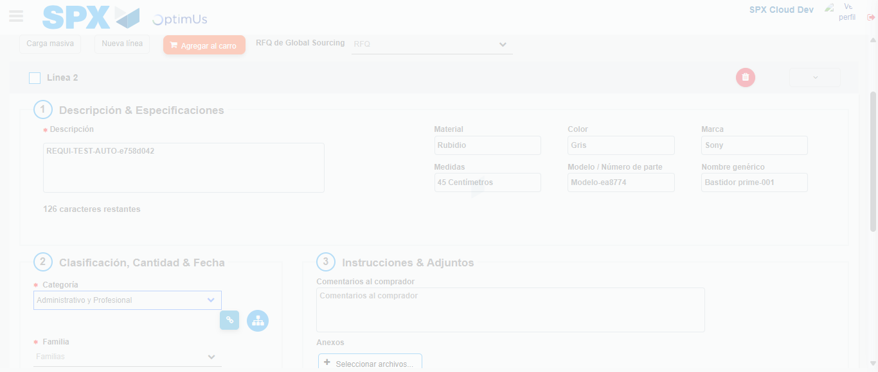Image file-name: QC_Testing-runTestMultipleTimes-dic. 04 2025, 03 43 31 p. m.

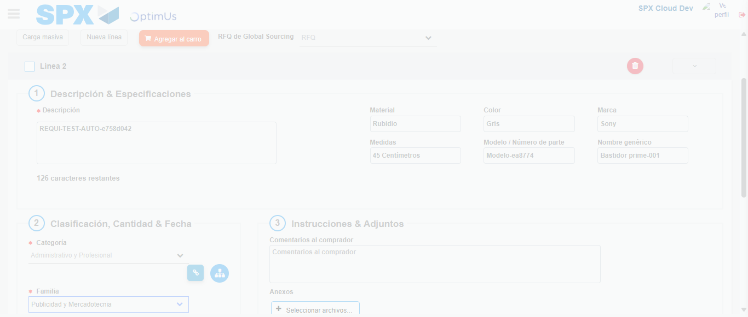Image file-name: QC_Testing-runTestMultipleTimes-dic. 04 2025, 03 43 32 p. m.

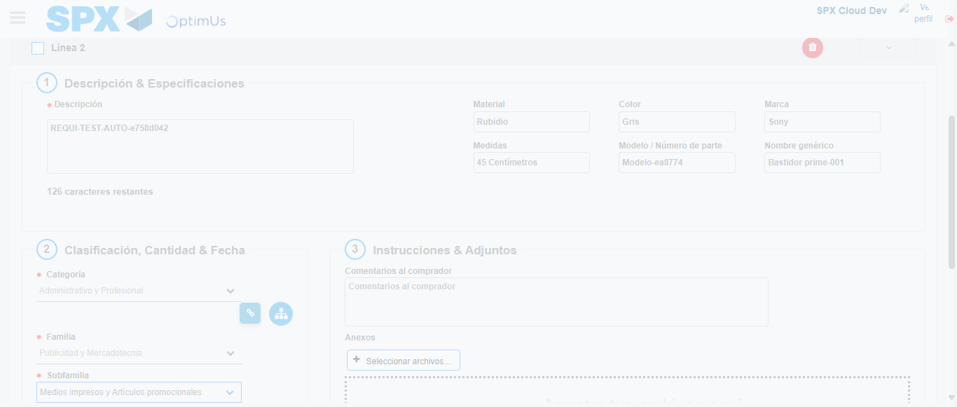Image file-name: QC_Testing-runTestMultipleTimes-dic. 04 2025, 03 43 33 p. m.

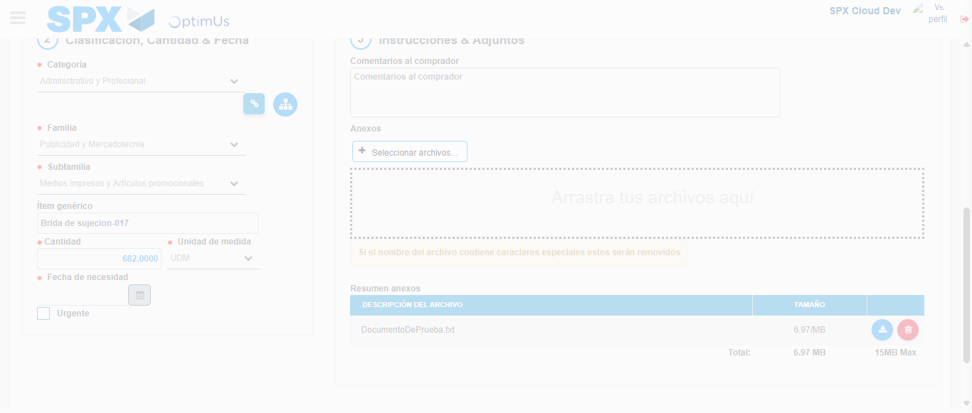Image file-name: QC_Testing-runTestMultipleTimes-dic. 04 2025, 03 43 34 p. m.

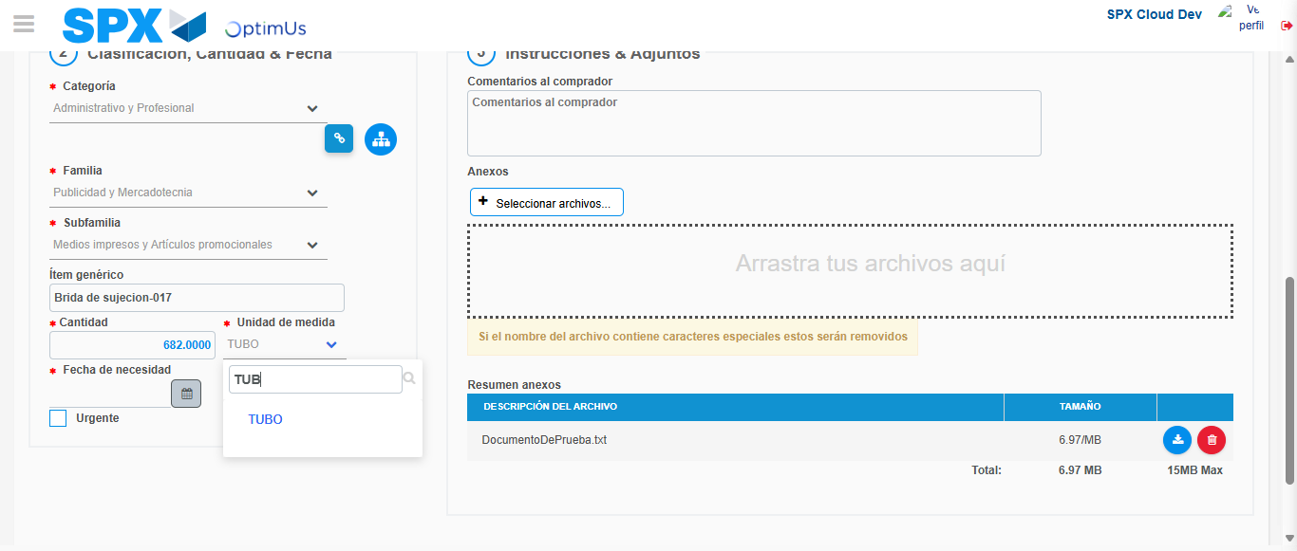Image file-name: QC_Testing-runTestMultipleTimes-dic. 04 2025, 03 43 35 p. m.

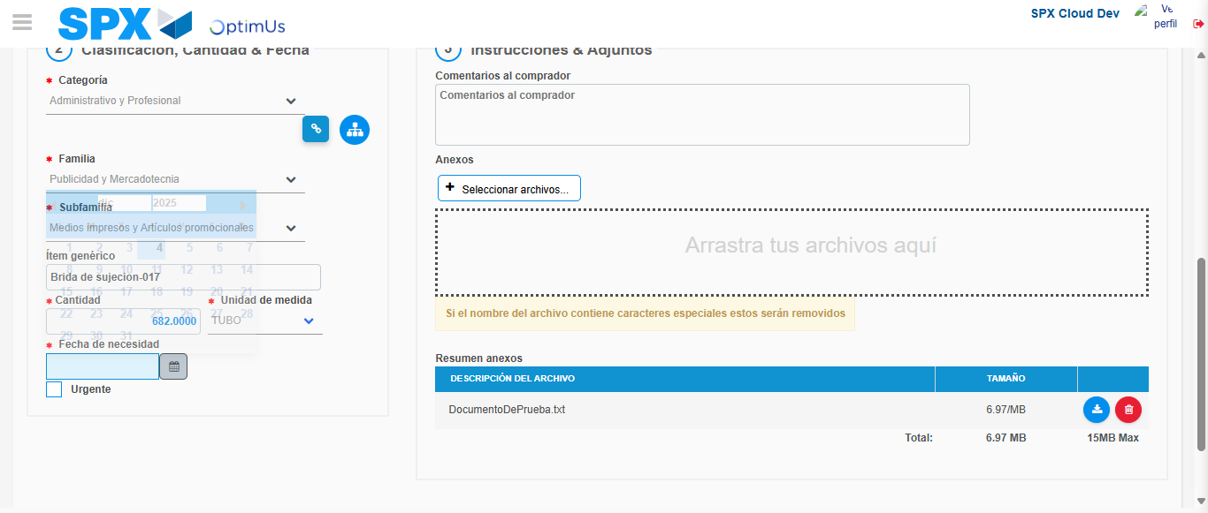Image file-name: QC_Testing-runTestMultipleTimes-dic. 04 2025, 03 43 36 p. m.

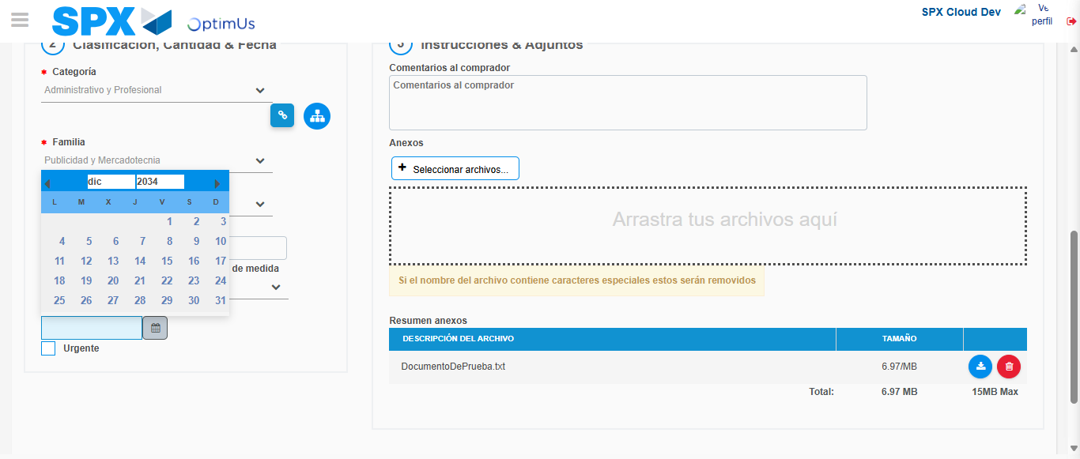Image file-name: QC_Testing-runTestMultipleTimes-dic. 04 2025, 03 43 37 p. m.

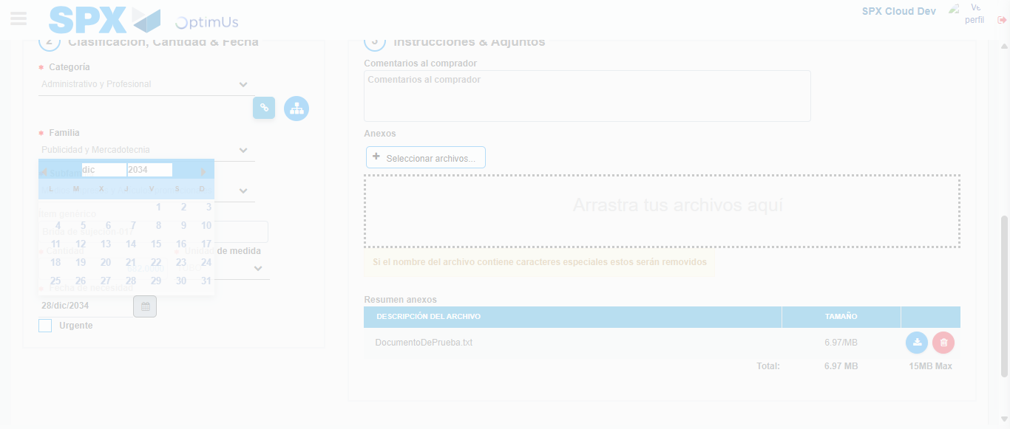Image file-name: QC_Testing-runTestMultipleTimes-dic. 04 2025, 03 43 38 p. m.

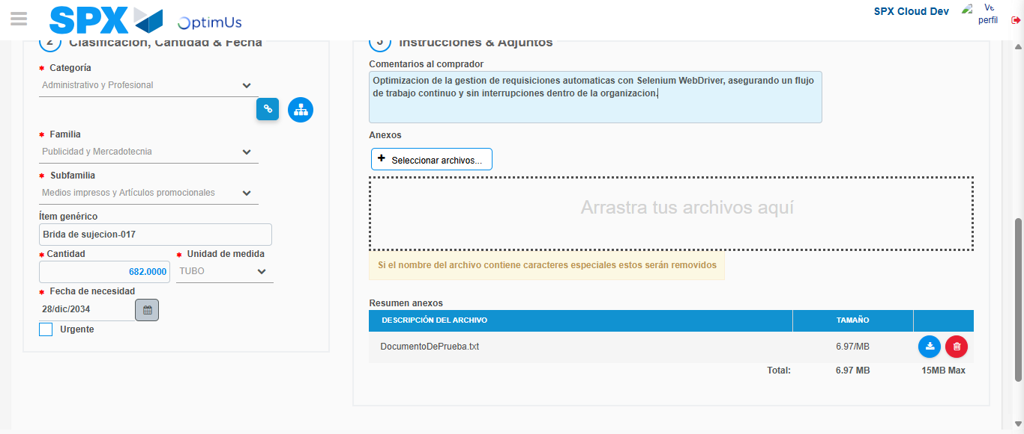Image file-name: QC_Testing-runTestMultipleTimes-dic. 04 2025, 03 43 39 p. m.

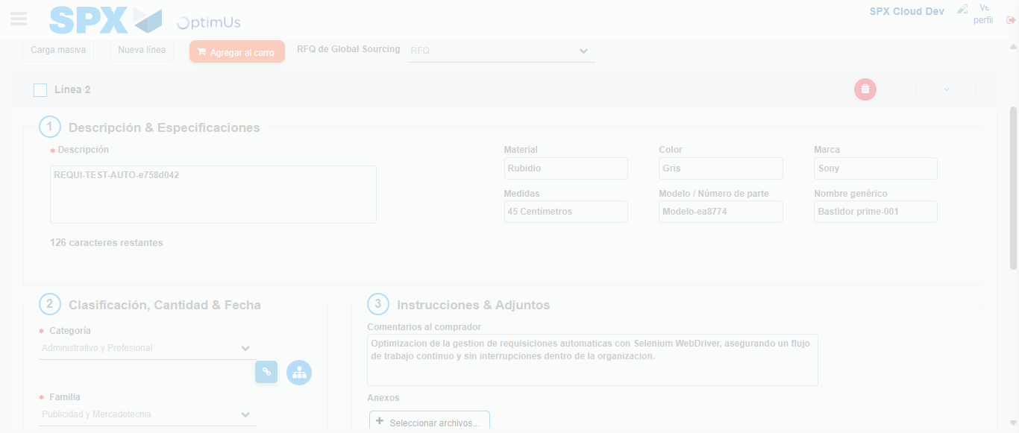Image file-name: QC_Testing-runTestMultipleTimes-dic. 04 2025, 03 43 40 p. m.

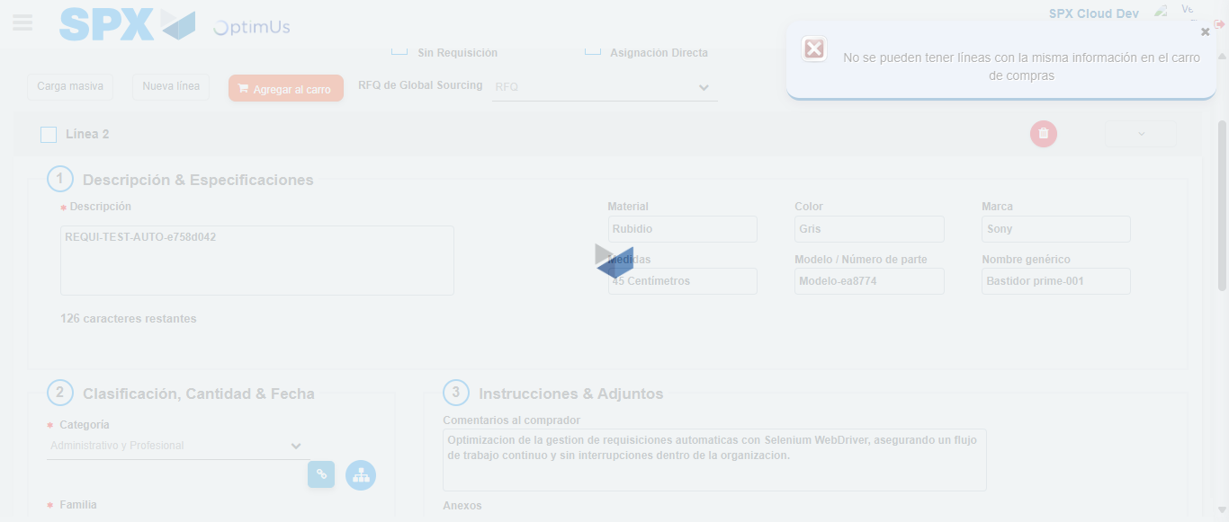Image file-name: QC_Testing-runTestMultipleTimes-dic. 04 2025, 03 43 41 p. m.

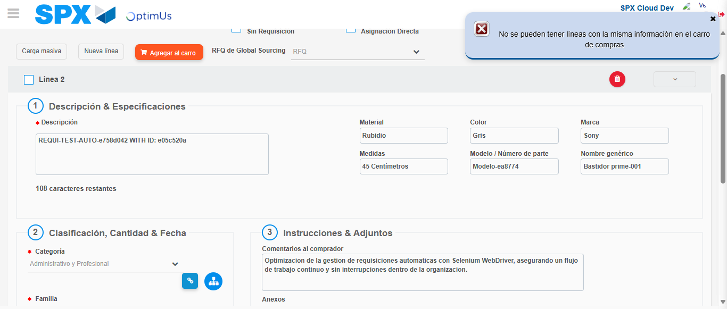Image file-name: QC_Testing-runTestMultipleTimes-dic. 04 2025, 03 43 42 p. m.

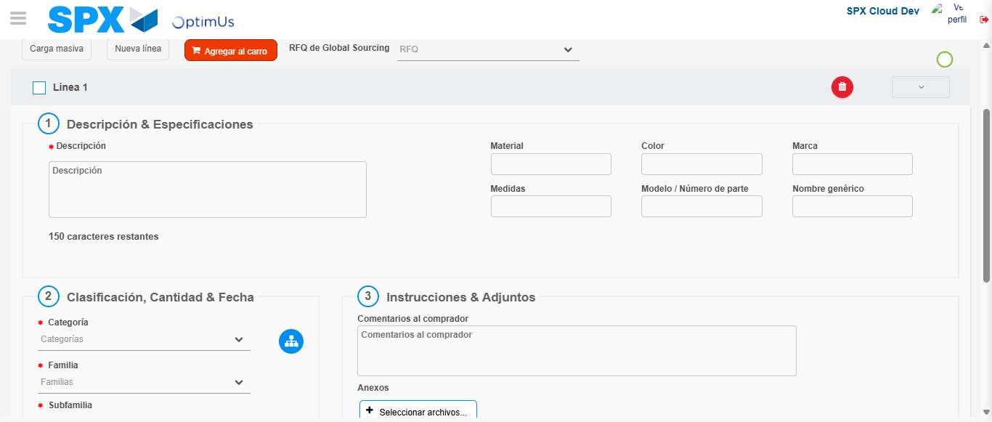Image file-name: QC_Testing-runTestMultipleTimes-dic. 04 2025, 03 43 46 p. m.

Step 5 - Select to Requisition: Requisition Correctly selected
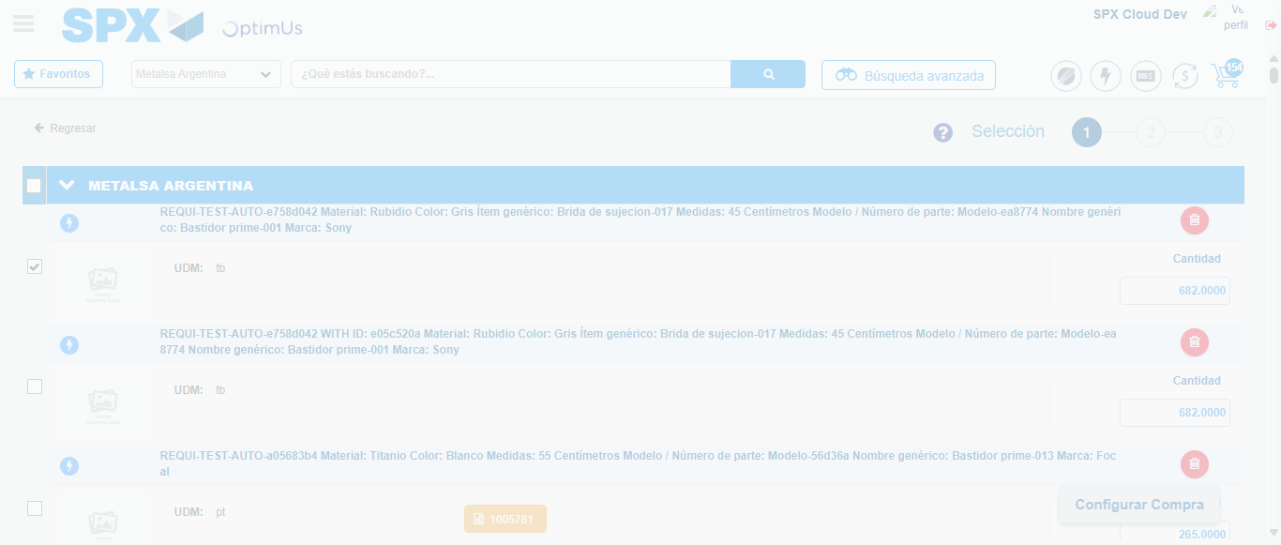Image file-name: QC_Testing-runTestMultipleTimes-dic. 04 2025, 03 43 55 p. m.

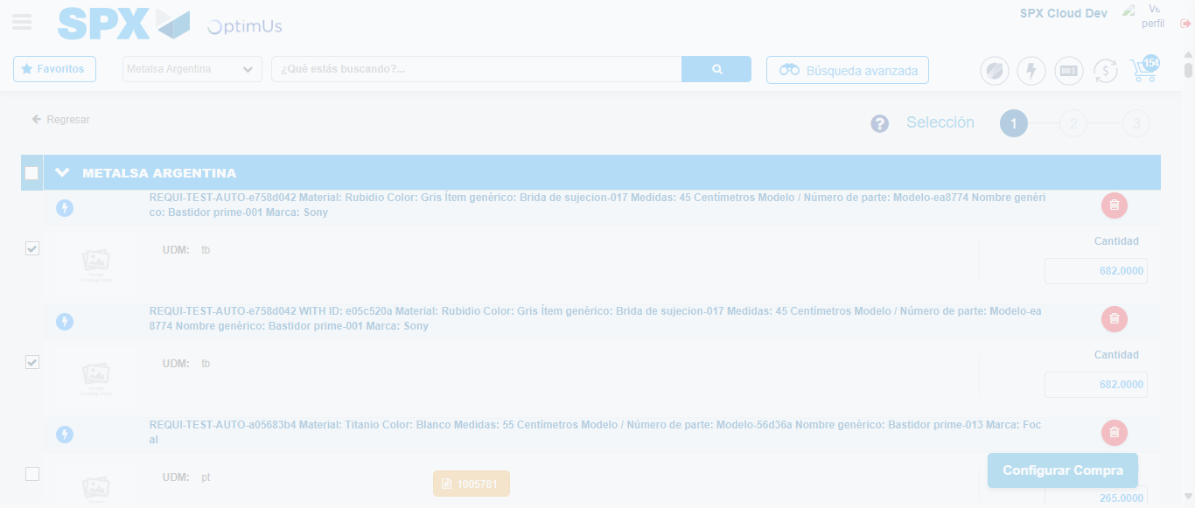Image file-name: QC_Testing-runTestMultipleTimes-dic. 04 2025, 03 43 56 p. m.

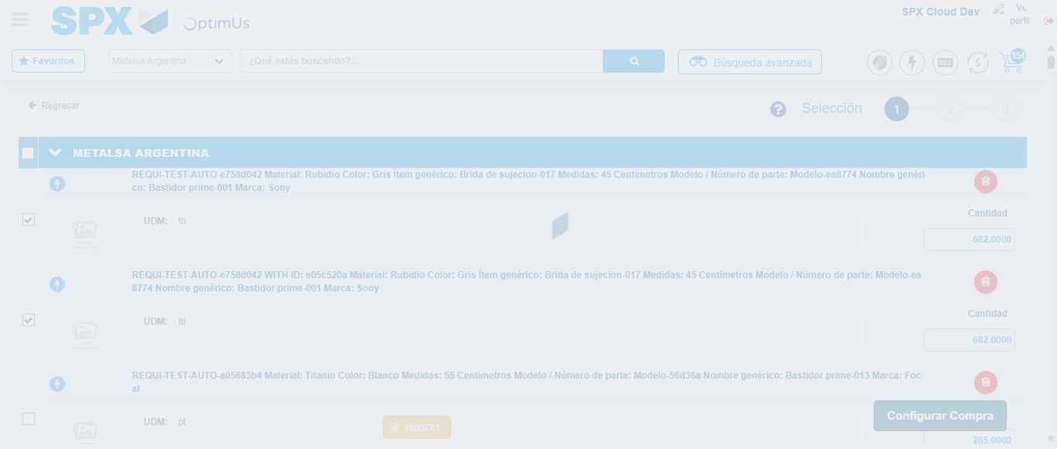Image file-name: QC_Testing-runTestMultipleTimes-dic. 04 2025, 03 44 00 p. m.

Step 6 - Select Type Account For Requisition: Type Account Correctly selected
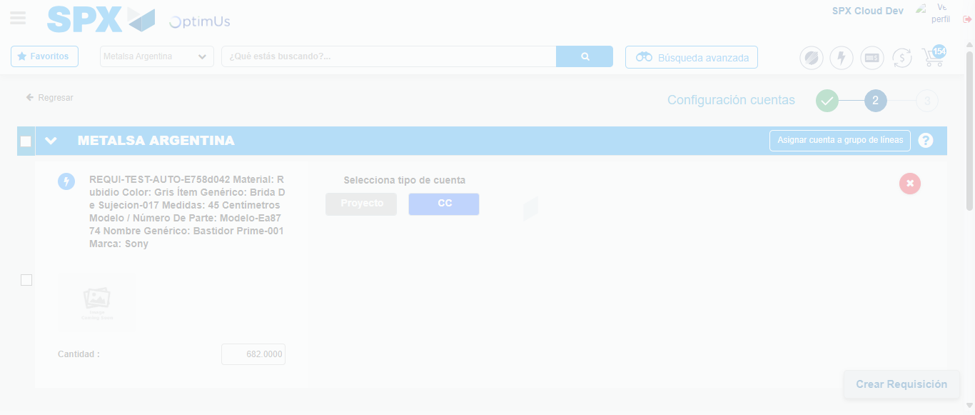Image file-name: QC_Testing-runTestMultipleTimes-dic. 04 2025, 03 44 06 p. m.

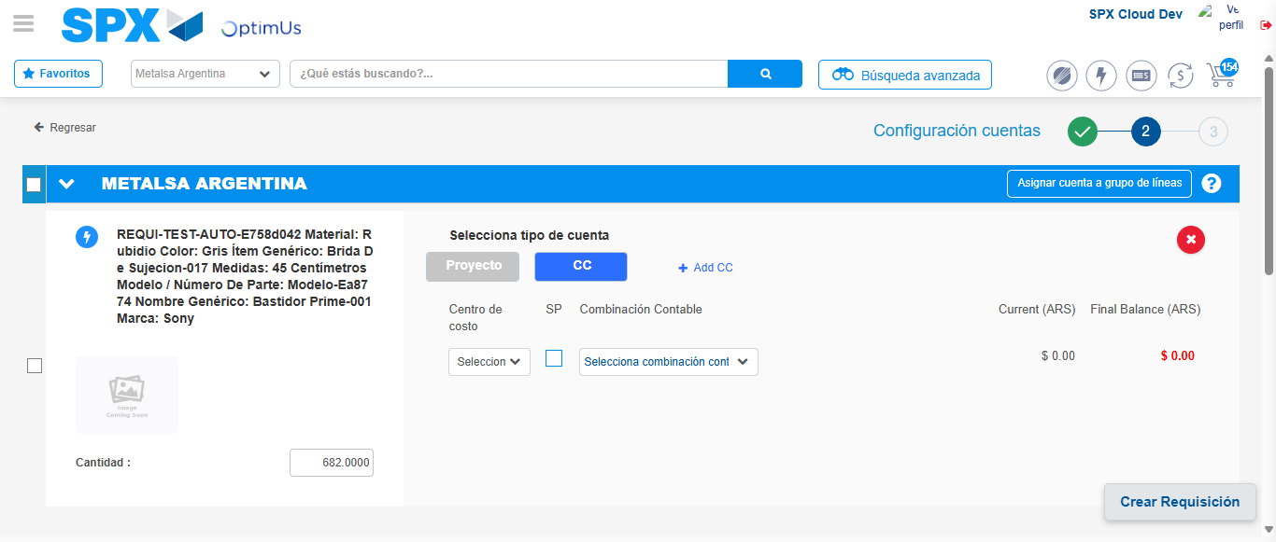Image file-name: QC_Testing-runTestMultipleTimes-dic. 04 2025, 03 44 09 p. m.

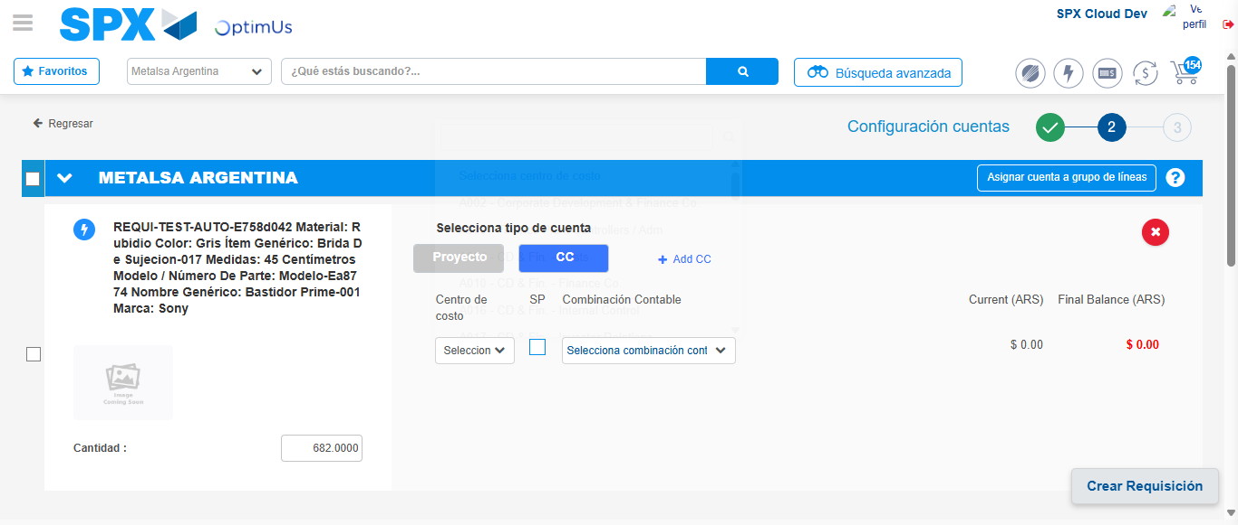Image file-name: QC_Testing-runTestMultipleTimes-dic. 04 2025, 03 44 12 p. m.

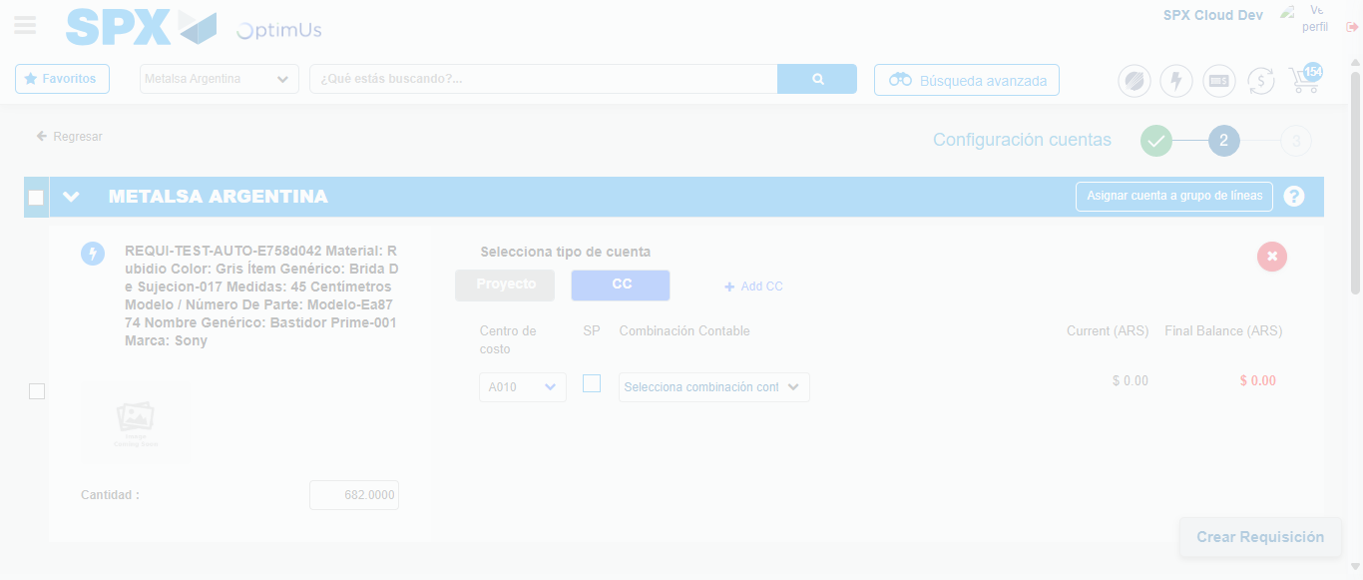Image file-name: QC_Testing-runTestMultipleTimes-dic. 04 2025, 03 44 13 p. m.

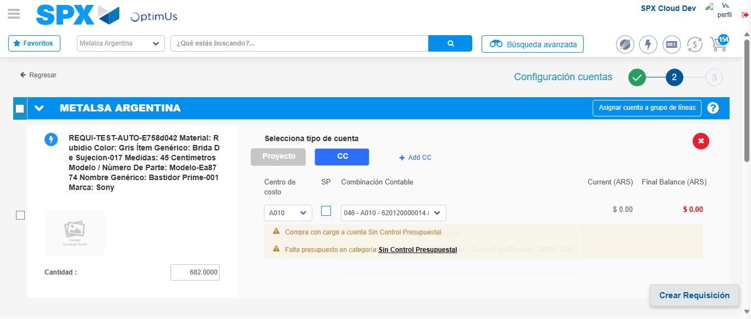Image file-name: QC_Testing-runTestMultipleTimes-dic. 04 2025, 03 44 16 p. m.

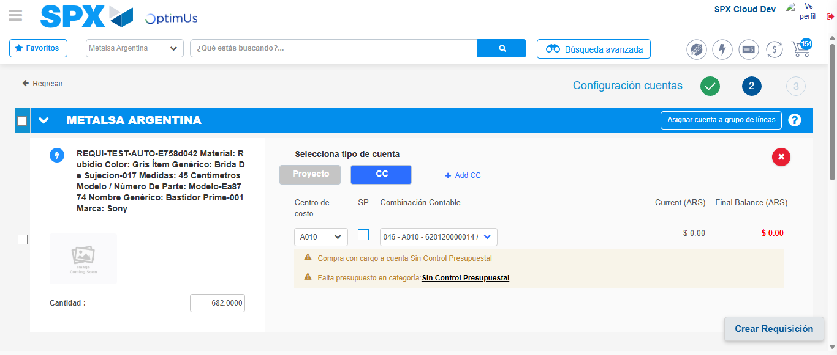Image file-name: QC_Testing-runTestMultipleTimes-dic. 04 2025, 03 44 17 p. m.

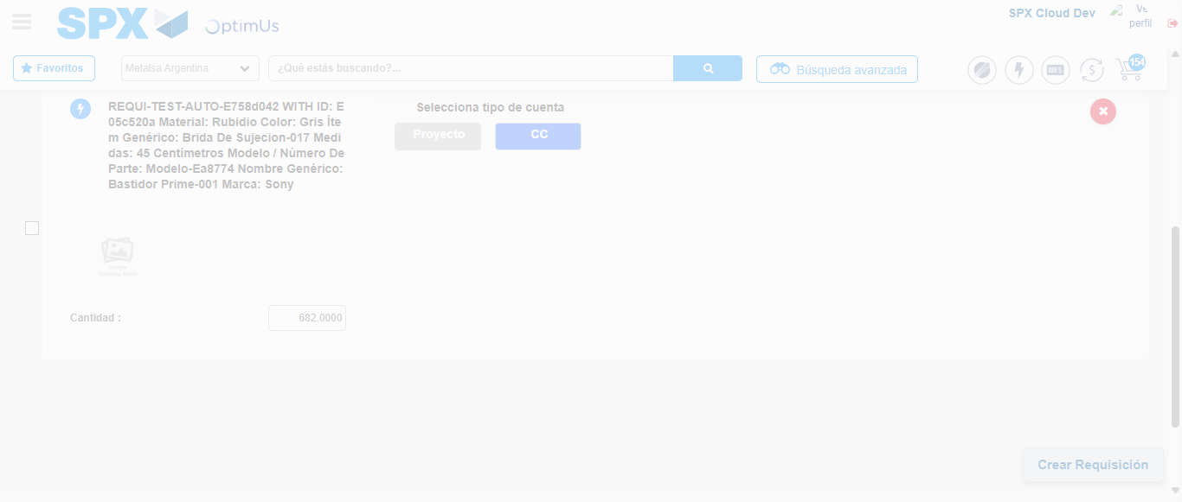Image file-name: QC_Testing-runTestMultipleTimes-dic. 04 2025, 03 44 23 p. m.

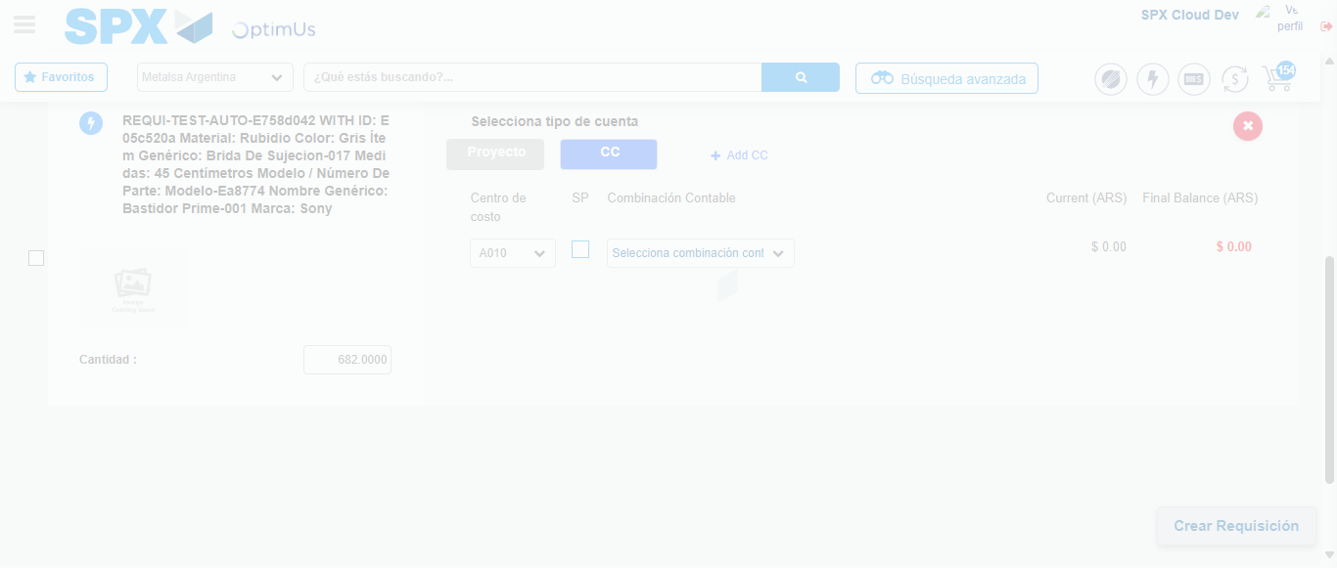Image file-name: QC_Testing-runTestMultipleTimes-dic. 04 2025, 03 44 27 p. m.

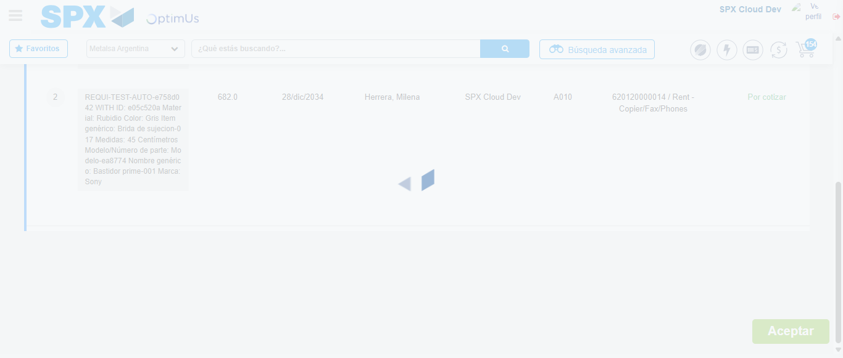Image file-name: QC_Testing-runTestMultipleTimes-dic. 04 2025, 03 44 31 p. m.

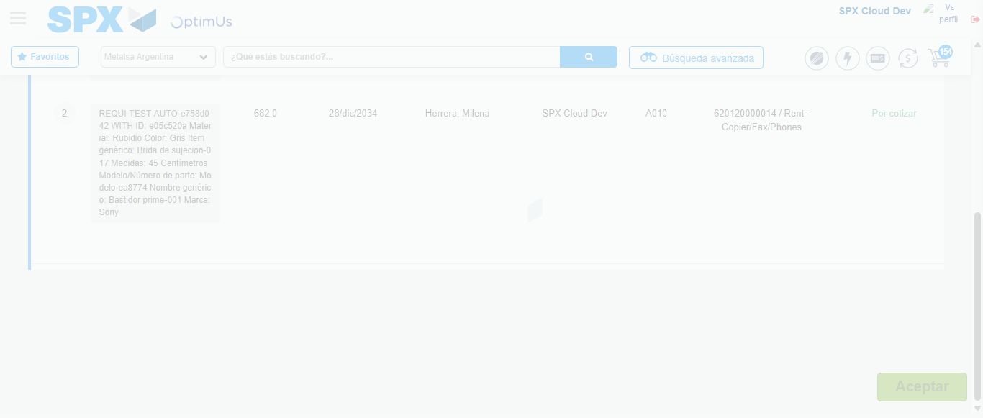Image file-name: QC_Testing-runTestMultipleTimes-dic. 04 2025, 03 44 32 p. m.

Step 7 - Accept to Requisition: Requisition Accepted
Image file-name: QC_Testing-runTestMultipleTimes-dic. 04 2025, 03 44 32 p. m.

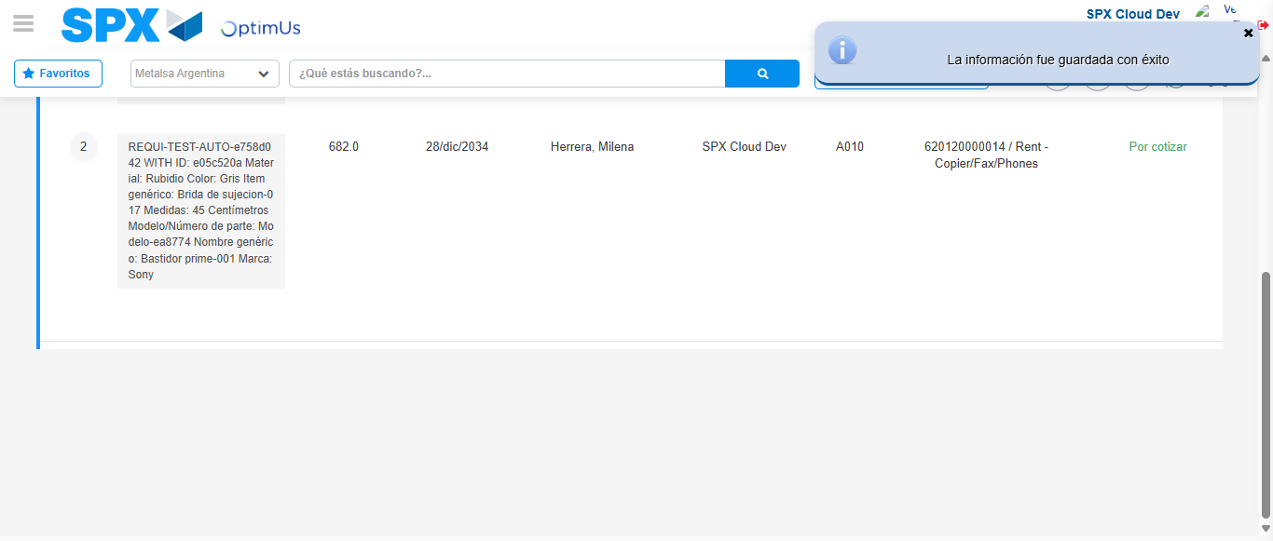Image file-name: QC_Testing-runTestMultipleTimes-dic. 04 2025, 03 44 35 p. m.

